1.**Отображение содержимого корзины** в **brick-standard.blade.php** (c **bootstrap**-кнопкой **remove** (**!но, только для cart, не для index**)):

-app\Http\Controllers\**GoodController.php**

/**

* Show the application of cart-page.

*

* @return \Illuminate\Contracts\Support\Renderable

*/

public function **cart**()

{

**$goods** = $this->repository->**showCart**();

return view('good.cart', [**'goods' => $goods**]);

}

+resoutrces\...\**cart.blade.php**

<h3>Cart</h3>

@php

print_r(**$goods**);

@endphp

+тут же **таблицу** из **index.blade.php**

<h3>Cart</h3>

@php

**//**print_r($goods);

@endphp

**<table>**

**<thead>**

**<tr>**

**<td class="widthbutton">&nbsp;</td>**

**<td>Image</td>**

**<td>Name</td>**

**<td>Price</td>**

**</tr>**

**</thead>**

**<tbody id="pannel">**

**@include('good.brick-standard')**

**</tbody>**

**</table>**

-resources\...\**brick-standard.php** (чтобы был **один для index и car**t, но **для последнего была кнопка удаления**):

@foreach($goods as $good)

<tr>

**@if (\Request::is('cart'))**

<td class="center widthbutton"><a class="btn btn-danger listbuttonremove" href="#"><i class="fa fa-trash-o" aria-hidden="true"></i></a></td>

**@endif**

…

<td>

**@if (\Request::is('/'))**

<a href="{{ route('product', ['id' => $good->id]) }}">

**@endif**

<img class="img_little" src="{{ asset('public/images/' . $good->image) }}" alt />

**@if (\Request::is('/'))**

</a>

**@endif**

</td>

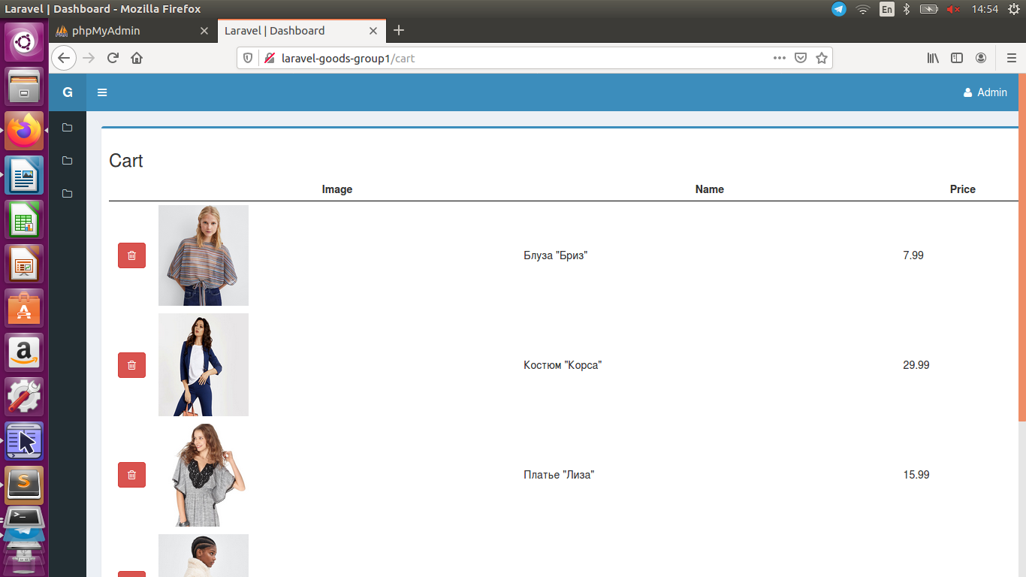

2.**Remove-all from cart (submit)**

-**button (+form)** из **product.blade.php**

</table>

**<hr>**

**<div class="box-footer">**

**<button type="button" class="btn btn-danger button_clearcart">Clear Cart</button>**

**<form name="form_clearcart" method="post" action="" style="display: none;">**

**{{ csrf_field() }}**

**</form>**

**</div>**

+@section('js')

<script>

$(document).ready(function(){

$('.button_**clear**cart').click(function(){

form_**clear**cart.submit();

});

});

</script>

@endsection

-**action** для формы **action="{{ route('clearcart') }}"**

+роут Route::name('**clearcart**')->**post**('/clearcart', 'GoodController@**clearcart**');

-**GoodController.php**

...

use App\Models\Product;

**use App\Models\Cart;**

class GoodController extends Controller

{

/**

* The GoodController instance.

*

* @var \App\Http\Controllers\GoodController

*/

protected $repository;

**protected $model_product;**

**protected $model_cart;**

/**

* Create a new controller instance.

*

* @return void

*/

public function __construct(GoodRepository $good, Product $product**, Cart $cart**)

{

//$this->middleware('auth');

$this->repository = $good;

**$this->model_product = $product;**

**$this->model_cart = $cart;**

}

/**

* Show the application of home-page.

*

* @return \Illuminate\Contracts\Support\Renderable

*/

public function index(Request $request)

{

$goods = $this->repository->funcSelect($request);

// Ajax response

if ($request->ajax()) {

return response()->json([

'table' => view("good.brick-standard", ['goods' => $goods])->render(),

]);

}

return view('good.index', ['goods' => $goods]);

}

/**

* Show the application of home-product.

*

* @return \Illuminate\Contracts\Support\Renderable

*/

public function product($id)

{

$product = $this->model**_product**->find($id);

return view('good.product', ['product' => $product]);

}

/**

* Show the application of cart-page.

*

* @return \Illuminate\Contracts\Support\Renderable

*/

public function cart()

{

$goods = $this->repository->showCart();

return view('good.cart', ['goods' => $goods]);

}

/**

* Store thing to cart.

*

* @return \Illuminate\Contracts\Support\Renderable

*/

//public function tocart(Request $request)

public function tocart(CartRequest $request)

{

$this->repository->store($request);

return redirect(route('home'));

}

/**

* Clear cart(all).

*

* @return \Illuminate\Contracts\Support\Renderable

*/

public function **clearcart()**

**{**

**$this->model_cart->truncate();;**

**return redirect(route('home'));**

}

